**Brooklyn torah gazette**

**For parshas vayakhel-pekudei 5781**

Volume 5, Issue 29 (Whole Number 229) 29 Adar 5781/ March 13, 2021

**Printed L’illuy nishmas Nechama bas R’ Noach, a”h**

For a free subscription, please forward your request to [***keren18@juno.com***](mailto:keren18@juno.com)

Past emails can be found on the website **ShabbosStories.com**

# Rav Avigdor Miller

# On Divided Loyalty



**QUESTION:** **We have an obligation to love Hashem and to love our fellow Jews. Whom do we have to love more, G-d or man?**

**ANSWER:** You have to love Hakadosh Baruch Hu b’chol livavcha, with all your heart so that leaves no space for any competition. Only that Hakodosh Boruch Hu says that you have to obey Him and you have to love your fellow Jews – and by doing that, you are loving Hashem. Part of loving Hashem with all your heart is loving your fellow Jew. If a person however forgets about Hashem and he thinks he’ll concentrate with all his heart on loving his fellow man, that man is wasting his life.

Now, it’s a great thing to love your fellow man – but that’s only if you do it in the service of Hashem. If you do it because you love Hashem, then you’re living successfully. And therefore there’s no question about the answer: You have to love Hashem with all your heart means that there’s no room for anything else.

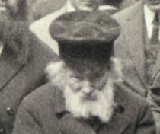

**The Chofetz Chaim**

The Chofetz Chaim we are told was a very kindly man. He went out of his way to help people. But he wasn’t exceptional in inviting people to his home. He used to help people find places to stay. He used to pay money to support them when they were visiting in his town. He paid for their lodging, for their food. But to take people into his home, he didn’t do that if someone else could do it – he wasn’t so generous.

And somebody explained that this was because he didn’t want to divide his loyalties to Hashem. He couldn’t be a crony, he couldn’t sit around all evening talking with his guests. He used to spend his time studying the Torah or even in solitude with Hakodosh Boruch Hu.

A man who is in love with Hashem can’t share his time freely with other people. And so although the Chofetz Chaim’s heart was in gemilas chassadim – he was instrumental in founding free loan societies everywhere. He was busy helping poor brides and poor yeshiva men. He gave advice to everyone; he was available for all those in need.

He did all the good deeds that you can imagine. And yet he didn’t spend much time with other people; if he could avoid being a crony and hanging around together with people, that’s what he did. Because to do otherwise detracted from his loyalty, his allegiance and his clinging to Hashem. And לבבך בכל means with all your heart, with no divided loyalties.

***Reprinted from the March 2, 2021 email of Toras Avigdor (Tape #555***

**The Unique Aspect of Moses**

**Towards the Sanctuary**

**From the Talks of the Lubavitcher Rebbe**

**Rabbi Menachem Mendel Schneerson, Zt”l**

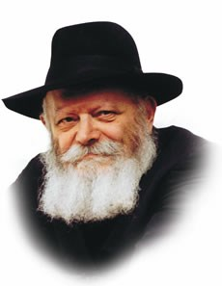

The second of this week's two Torah portions, Pekudai, relates how Moses made a personal account of all the silver and copper that was donated to build the Sanctuary. The purpose of this inventory was to remove any doubt that the donations were not being utilized for their intended purpose.

The Midrash, however, relates that Moses came up short when tallying the amount of silver: 1775 shekalim of silver were unaccounted for. At that moment, a heavenly voice rang out and proclaimed, "The 1775 [shekalim of silver] were used to make the hooks of the pillars." In this way G-d declared Moses to be beyond all suspicion, as it states, "Not so My servant Moses; in My entire house he is [the most] faithful."

A question is asked: If G-d's sole intent was to attest to Moses' honesty, why was it necessary for him to make an account in the first place? Why couldn't a "heavenly voice" have proclaimed Moses' faithfulness without his having to actually go through the process of counting?

We learn from this that there was a deeper intent behind Moses' taking inventory, a purpose that went beyond merely tabulating the amounts of precious metals that were donated or to remove suspicion.

Rather, Moses played an integral role in the function of the Sanctuary itself, as will be explained.

**Individual Contributions and a National Enterprise**

Although the Sanctuary was erected with the contributions of individuals, at the same time, it was a product of the Jewish people as a whole. This transformation -- from a collection of donations made by disparate individuals into an entirely new, collective entity -- was brought about by Moses, the leader of the generation.

When an individual Jew makes a contribution, his state of mind is an important factor. Some people make a donation willingly and with all their heart, while others are more hesitant. Moses, however, the Jewish "king," whose "heart is the heart of the congregation of Israel," was able to combine and unite the singular contributions and turn them into a collective whole.

One of the reasons the Sanctuary is called "the Sanctuary of testimony" is that the Divine Presence resting within it attested to G-d's having forgiven the Jewish people for the sin of the Golden Calf.

Moses, the only Jew who remained absolutely untainted by the sin, was thus the only person who could effect this transformation and cause G-d's Presence to dwell in the physical world.

*Reprinted from the 5756/1996 Ki Sisa edition of L’Chaim Weekly.*

**A Thought for the Parsha**

*And Moses blessed them* (Exodus 39:43)

What was Moses' blessing? "May it be G-d's will that the Divine Presence rest on the work of your hands."

In other words, holiness and G-dliness must be brought into all aspects of a Jew's life -- not just his spiritual relationship with G-d, but even his business dealings with his fellow man. *(Divrei Asher)*

*Reprinted from the Parshat Vayakhel-Pekudei 5756/1996 edition of L’Chaim Weekly.*

**R’ Avraham Abulafia, zt”l**

Rav Avraham Abulafia, Zt”l, born 1240 – died after 1291. In his own day, R’ Avraham was considered by many to be a false messiah. Five hundred years later, however, the widely accepted posek/halachic authority, R’ Chaim Yosef David Azulai (“Chida”) would write:

You should know that Rashba in his responsa, No. 548, and Rav Yashar [i.e., R’ Yosef Shlomo Delmedigo] denigrated him [i.e., R’ Avraham] like one of the lowliest people. However, I will tell you the truth that I saw a great rabbi, from the masters of kabbalah whose name is great amongst the Jews and whose word no one can doubt, who drew [R’ Avraham’s works] close.

Later writers stated that the “great Rabbi” referred to was R’ Moshe Cordevero. R’ Chaim Vital also quotes R’ Avraham extensively. At age 20, R’ Avraham set out in search of the Ten Lost Tribes, but he was turned back by the Crusaders when he reached Akko (Acre).

On his return trip to Spain, he stopped in Italy, where he studied Rambam’s Moreh Nevuchim/Guide to the Perplexed. Dissatisfied with this branch of learning, he turned to kabbalah. Later, he wrote a kabbalistic commentary to Moreh Nevuchim called Moreh Ha’moreh.

After settling in Spain, he devoted himself to studying the ancient work Sefer Yetzirah, with the commentary, in particular, of R’ Elazar of Worms. R’ Avraham also began teaching his own students, most notable among them, R’ Yosef Gikatilla.

After 1280, R’ Avraham settled in Messina, Sicily, where he began preaching of the imminent coming of mashiach. The confused citizens of Messina turned to Rashba, the generation’s foremost Torah authority, for advice, and he warned the community not to become involved with a false messianic movement. Next, R’ Avraham moved to Greece, where he composed several works in his own defense. He also composed additional kabbalistic works, leaving behind 48 books in total. (The Artscroll Rishonim ; She’eilot U’teshuvot Ha’Rashba; Shem Ha’gedolim, Ma’arechet Sefarim, Erech “Chayei Olam”; Ohr Hachaim - Hamaayan)

*Reprinted from the Vayakhel-Pekudei 5781 email of whY I Matter parsha sheet of the Young Israel of Midwood in Brooklyn as compiled by Reb Yedidye Hirtenfeld.*

**Rabbi Berel Wein on**

**Parshat Vayakhel-Pekudei 5781**

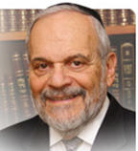

The book of Shemot concludes with the detailed accounting of the materials collected and used in the building of the Tabernacle. Even though this accounting may appear to us to be superfluous and even overly detailed, the words and letters that appear in this week's Torah reading are as holy and important as any others that appear in our holy Scriptures.

There is an important overriding lesson – a moral imperative – that is being imparted to us in the words of the reading of this week. That lesson can be summed up in that we are responsible for each of our actions and behaviors during the year, and during our lifetime. It is as if each of us signs our name at the bottom of the pages that record each of our activities in life with one word: accountability.

**We are Held to a Stricter Standard of Accountability**

Judaism holds its adherents to strict standards of accountability. Accountability in speech, in deeds and action, regarding financial income and expenses, and in all other matters of human interaction and relationships. We are informed by the prayer services of the High Holy days that each of us has pages in G-d's ledger book, so to speak, and that each of us signs with our own signature at the bottom of those pages to attest to the accuracy of that accounting.

The basis of all responsible human behavior is accountability. Without that, having good intentions and high hopes by human beings to accomplish good things are mostly doomed to failure and disappointment. It is only the concept of accountability that is the driving force that creates efficiency, and the feeling of spiritual advancement and accomplishment within us. Educational institutions that never administer exams or do not make demands upon its students are really cheating them out of the benefits that an education can bring to a person.

**A People Just Recently Freed**

**From Physical and Mental Bondage**

The Torah is exacting and meticulous in recording for us all the activities, donations, and actual results regarding the enormous task of constructing the Tabernacle in the middle of a wasteland, by a people just recently freed from physical and mental bondage. One could be fooled to say that in such circumstances any demand for accountability should be lenient, if not even muted. However, we see that the Torah makes no allowance for the inherent difficulties and stress that must have been involved in building the Tabernacle in the desert. In general, we can say that Judaism rarely, if ever, accepts excuses for poor performance or lack of effort, no matter how seemingly valid they might be. No excuse, no matter how good and valid it may be, ever equals accomplishing the task that was set out before the person to realize and fulfill.

The Torah wishes to impress upon us that accountability requires exactitude, paying of attention to what otherwise may seem to be small and unimportant, and an understanding that in the great picture of life there really are no small events or minor incidents that can be glossed over as though they never occurred. That is not our method of accountability. The Torah is never sloppy in dealing with human events.

*Reprinted from the current website of Rabbiwein.com*

**Thoughts that Count**

*And on the menora itself were four cups, shaped like almond blossoms, with its knobs and flowers* (Exodus 37:20)

According to Maimonides' detailed drawings, the 22 cups of the menora were "upside down," that is, the wider, open part of the cup was on the bottom, while the closed, narrower part was at the top.

The windows of the Holy Temple were similarly inverted -- narrower on the inside and wider on the outside.

Why? The function of the menora was to illuminate -- not just its immediate surroundings, but the entire world. Light did not filter in from without; rather, light spread from the Temple outward.

A regular cup is a vessel for drinking; an inverted cup pours its contents out for others -- hence the symbolism of the menora's cups. *(Likutei Sichot Vol. 21)*

*Reprinted from the Parshat Vayakhel-Pekudei 5781 edition of L’Chaim Weekly.*

**Parshas Pikudei**

**Columbus Discovered America – HASHEM Invented It**

**By Rabbi Bentzion Shafier**

**Founder of TheSmuz.com**

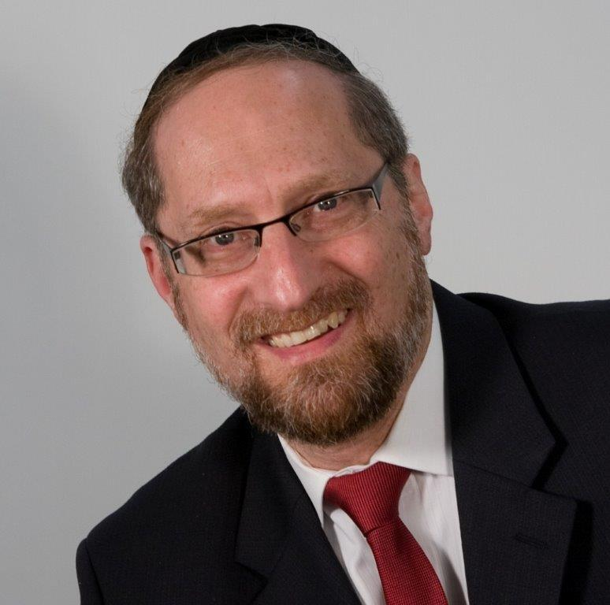

“*And they brought the Mishkan to Moshe, the tent and all of the vessels” — Shemos* 39:33

**It wasn’t Moshe’s action. It was a miracle.**

When all the parts of the Mishkan had been fashioned, they were brought to Moshe, who actually stood the walls up and erected the Mishkan. Rashi explains that because of the massive weight of the materials, none of the people involved in forming the Mishkan were able to erect it, so they brought the materials to Moshe. Moshe was also unable to lift up the heavy walls, so HASHEM said to him, “Go through the motions as if you are lifting them, and they will be lifted on their own.”

## How could the Torah say Moshe erected the Mishkan when he couldn’t do it?

The difficulty with this Rashi is that one posuk later (in 40:18) it says, “And Moshe erected the Mishkan.” Moshe is credited with actually putting up the Mishkan. Yet the Medrash tells us that not only didn’t he put it up, he wasn’t even physically capable of doing it. In what sense can the Torah consider that Moshe raised the Mishkan when it clearly wasn’t his action?

**Creative in name, but not in principle**

The answer to this question can be found by understanding any creative act of man.

When a couple makes the conscious decision to have a baby, they use a system that HASHEM put into place to bring forth a child. They don’t claim to be knowledgeable enough in anatomy to synthesize the proteins needed for growth. They don’t allege to have sufficient understanding in physiology to weave the neuron pathways in the brain. And they certainly don’t contend that they are learned enough in pathology to create the immune system that develops within their fetus.

When we say they made the baby, we mean they used a pre-existing system that was set up with great wisdom and forethought. They pushed the button, and the gears and flywheels went into motion. Nine months later, out came a perfectly-formed, complex marvel called a human. They had the baby, but they didn’t create the baby.

This is true of any creative act that a human engages in, whether it be a couple having a child, a farmer growing corn, or an entrepreneur creating an industry. We take pre-existing elements, use pre-formed systems, turn a switch, and take the credit for the result. In our minds’ eye, it is our effort that brought forth the product, but in reality, we did little but use the machinery already in place.

An analogy to this would be:

**Frank the cookie baker**

Every day, when Frank leaves work, he takes home two packages of freshly baked cookies for his kids. His children love to brag about the delicious cookies their father makes. Frank’s kids are the envy of the entire first grade. Naturally, when the class is planning on having a bake sale, who do they ask for help with the recipes? Frank!

Unfortunately, Frank doesn’t know that much about baking cookies. You see, Frank works in a factory. Every morning exactly at 4:20 AM, Frank pushes the switch that starts the operation rolling, and exactly 35 minutes later, out comes the first batch of Stella D’oro Chocolate Fudge cookies.

Frank didn’t create the process; he doesn’t even know which ingredients go into the mixture. He wouldn’t be able to tell you the different preservatives and flavoring that are used. He wouldn’t be able to explain to you the difference between radiant and convection heat and their effect on the crispness of the cookie. He certainly isn’t capable of creating the intricate system of conveyer belts, mixers, and feeder chain ovens needed to produce that cookie. His job is to flip the switch. The machine does the rest.

**Columbus discovered America – he didn’t invent it**

When man harnesses a force of nature, we look at him with awe and reverence. What a brilliant thinker! He invented something that wasn’t! Inadvertently, we attribute the wisdom of the system to the one who harnessed it.

This is a fallacy. It’s much like Columbus’ finding America – he discovered it, but he didn’t create it. When man taps into a powerful force in HASHEM’s world, he has created nothing. He has uncovered some of the intricacies of the **systems and machines that HASHEM uses to run this world.** Using systems, laws, principles, and entire machines already in place, man comes along and changes a gear. The effect may be significant, but he **created** nothing. He discovered a bit of the elaborate machinery that HASHEM brought forth in the six days of Creation.

**The difference between Moshe Rabbenu and us**

The answer to the question on Rashi seems to be that Moshe Rabbeinu understood that any action that he engaged in was but flipping the switch. It is HASHEM’s machine, and HASHEM’s rules run that machine.

If HASHEM said that today in this situation, going through the motions is what will bring about the results – then it is just a different way of flipping the switch. When Moshe went through the motions of lifting the Mishkan, the action was still attributable to him because HASHEM said that in regards to that situation, this was the system that He set up.

You wave your hands, and this will be the result. In that sense, Moshe used the system that HASHEM put into place. It was no different than a farmer planting wheat or a couple having a child. It’s all miraculous, and man’s role is always just going through the motions. As such, this was how Moshe erected the Mishkan. He used HASHEM’s machine to bring about the result.

This understanding is pivotal in our understanding of HASHEM’s involvement in nature and the running of this world, and it focuses our perspective of our own involvement in this world.

*Reprinted from the website of Theshmuz.com.*

**The Conversion Controversy**

**By Rabbi Steven Pruzansky**

***The Courts have no more right to opine on “who is a Jew” that they have to move Shabbat to Tuesday or Pesach to the winter***

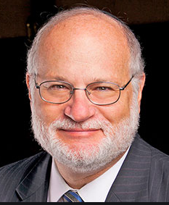

The Israeli High Court’s decision mandating the acceptance of non-Orthodox conversions in Israel as proof of Jewish status only for purposes of citizenship is not as momentous as it sounds. The original sin, so to speak, was the language in the amended Law of Return that severed “conversion” from “according to halakha.”

**A Sad Commentary on the Political Establishment**

That was followed by a capitulation to the non-Orthodox leadership in the United States that allowed *their* spurious conversions in the exile to be accepted here as well for the purposes of citizenship. Extending this concession to such conversions that occur in Israel is natural; failure of the political establishment to deal with this matter appropriately for over a decade is a sad commentary on the political establishment and its paralysis. But the decision affects so few people that it is no big deal *per se*.

Why then is it misguided and dangerous? Because it reflects a complete lack of awareness of the nature of the heterodox movements and their deleterious effects on Jewish life in the exile. Aside from the the assault on Jewish identity, facilitated by the High Court and abetted by the pusillanimity of the political class, is staggering. absurdity of lumping together all non-Orthodox conversions (in the United States, even the Conservative movement does not accept Reform conversions!), the decision further drives a stake into the concept of a Jewish state. While eliminating the Law of Return may be an ultimate goal of the religious and political left, the current dilution of the Jewishness of the state promoted by this decision has long term consequences.

**If Israel Becomes a Jewish State in Name Only**

If Israel becomes a Jewish state in name only, but not in identity or in practice, social cohesion, already under siege, will deteriorate even further.

No one has ever delegated to the Knesset or the High Court the right to determine “who is a Jew.” At most, they are authorized to determine “who is an Israeli,” and injudicious decisions like this one further divide people and inflame the Torah world against the State. The branches of government have no more right to opine on “who is a Jew” that they have to move Shabbat to Tuesday or Pesach to the winter. In truth, they can declare that any Mongolian, Zambian, Brazilian or American to be eligible for Israeli citizenship, but then at what cost to the concept, value and vision of Israel as the “Jewish State”?

What makes this decision even more risible is that it exposes a profound lack of awareness about the insidious failures of the Reform movement in America. Look no further than a recent [article](https://forward.com/opinion/465137/jews-of-color-seminaries-intermarriag/) in the *Forward* entitled “To truly welcome Jews of color, seminaries must ordain intermarried rabbis.” The article is mindboggling in a number of ways.

**Reform Judaism Risks Being Accused of Racism**

Its main thesis is that Reform Judaism risks being accused of racism since it has so few black rabbis. The reason why it has so few black rabbis is that, apparently, most eligible Reform Jewish black men and women are in interfaith “relationships,” either married or living together without the formality of marriage. Since Reform presently does not accept those in interfaith relationships into their rabbinical school, the “unintended impact” of the anti-interfaith-rabbinical-students decree is that there are thus few black rabbinical candidates.

Aside from the sheer insanity of seeing *everything*in terms of race – something that, literally, only racists do, and which today is an American obsession bordering on pathology – understand the various ways in which the argument is offensive to Jews, Jewish values, and Israeli life.

Currently, only the Reconstructionists welcome intermarried clergy, which presumably means that their converts abroad and now in Israel must be accepted as Israeli citizens – even if they were “taught” their Judaism from their intermarried “rabbi.” Even Reform has not taken the step of welcoming intermarried clergy, as they still expect their “rabbis to be exemplars of a Jewish home.” Hence the chagrin of the writer.

**Two Facts that Should Shock Israelis**

But he points out two facts that should shock Israelis and awaken them to the true catastrophe of the Reform movement in America and the sheer lunacy of importing it to Israel. According to this Reform Jew, “at least 72% of new Jewish homes are formed by interfaith couples.” Digest that – overwhelmingly, most marriages in America today involving a Jew are intermarriages, and factor out the Orthodox population, intermarriage in America is an uncontrolled avalanche destroying any semblance of real Jewish life.

Additionally, he unwittingly notes the toll intermarriage has already taken on American Reform Jews. One reason why the hindrance to accepting the intermarried into Reform rabbinical school is upsetting to the writer is the astronomical rate of intermarriage means that “40 to 60% of [the] eligible pool of students isn’t eligible.” That means that so many Reform adults who might consider the rabbinate are already involved in interfaith relationships themselves. And this doesn’t even address the tragic reality that most Reform Jewish children are not Jews according to halakha.

**Reform Converts in America are Rare**

Reform converts in America are rare in any event as Reform Judaism does not require conversion for the sake of marriage and most Reform rabbis will officiate at intermarriages. Presumably, most Reform conversions (obviously *pro forma* and not requiring Kabbalat Hamitzvot) are performed for the purpose of appeasing a traditional relative – or for Aliya. And that new *oleh* or *olah* might well have been trained by a rabbi who is either not Jewish or, if the current policy is changed, by a rabbi is in an interfaith relationship. Invariably, the policy will be changed, as liberal Jews in America cannot endure an accusation of racism. But what kind of Judaism is that? What could they be taught?

The assault on Jewish identity, facilitated by the High Court and abetted by the pusillanimity of the political class, is staggering. The implications for the State of Israel are enormous if the organs of the State make a conscious decision to ignore true Jewish identity and commitment in its drive to be a state of all its citizens and perhaps of the world.

Maybe the very idea of a “Jewish state” has become too parochial for the leftist internationalists who are in positions of power. That a tiny number of rabbis on the left fringe of Orthodoxy (or in the neo-Conservative camp) endorse this decision for the unity they think it will provide is fanciful, and they too ignore the calamity that non-Orthodoxy has wrought to American Jewish life.

This virus has no vaccine but it has a known prognosis: total assimilation, renunciation of Judaism and Jewish life, anti-Israel activism, and then hatred. It should not be imported to Israel.

Politicians should clearly express a commitment to passing in the next Knesset the *“chok hahitgabrut”* that will rein in the High Court’s jurisdictional and legislative excesses, and then pass a law confirming true Jewish identity as the foundation of the Law of Return. That will both bolster Israel’s Jewish identity and send a clear message to our non-Orthodox brothers and sisters – the relative few that are still Jews according to halakha – that the road to return is open to them, and they will be welcomed when they travel on it.

*Rabbi Pruzansky was for decades a pulpit rabbi in the United States, currently is the Israel Representative of the Coalition for Jewish Values, and resides in Israel.*

*Reprinted from the March 5, 2021 email of the Arutz Sheva.*

**Final Thought on the Parsha**

*All the work of the Sanctuary of the Tent of Meeting was finished, and the children of Israel did all that G-d commanded Moses* (Exodus 39:32)

Once the Sanctuary was completed, sacrifices could then be brought to serve as atonement for sins. Nonetheless, the Jewish people continued to keep all the Torah's commandments, even as they brought their offerings. *(Rabbi Shlomo Kluger)*

*Reprinted from the 5756/1996 Ki Sisa edition of L’Chaim Weekly.*